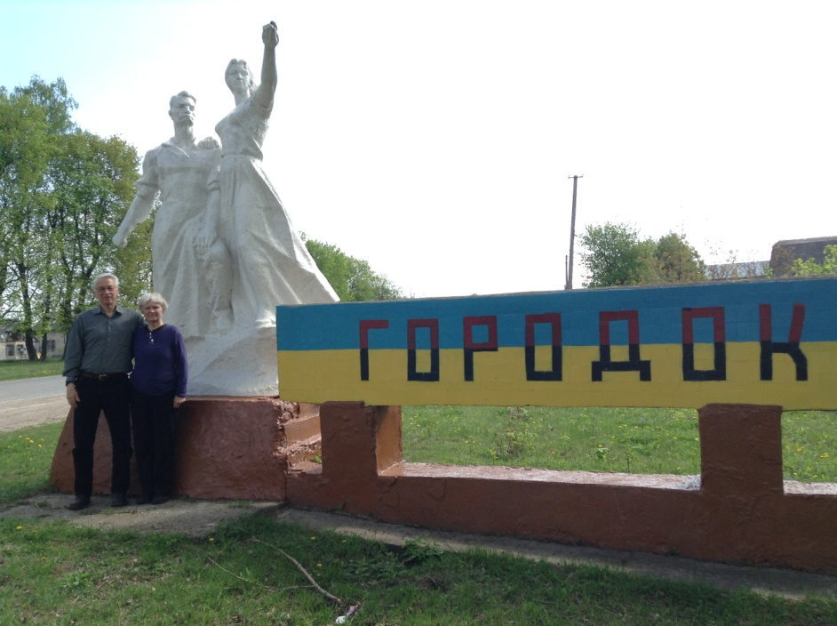
Entrance to Gorodok

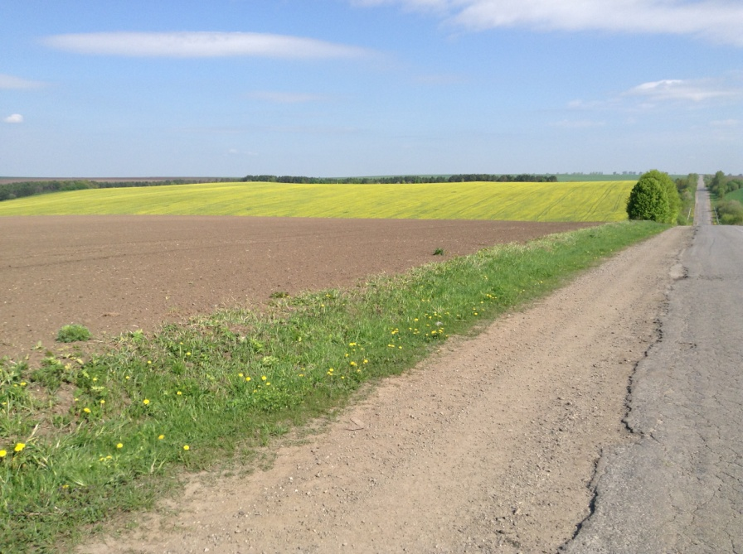
Field outside of Gorodok
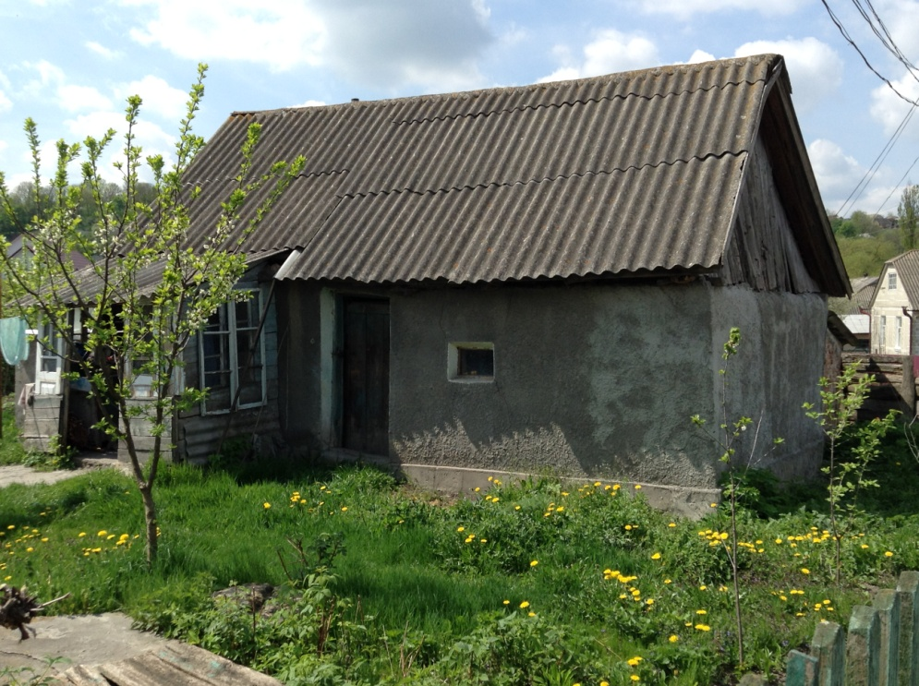
Old style house in Gorodok
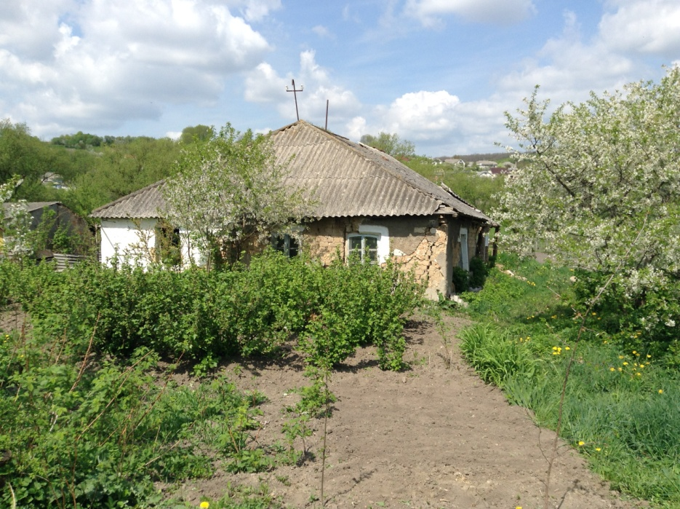
Another old style house
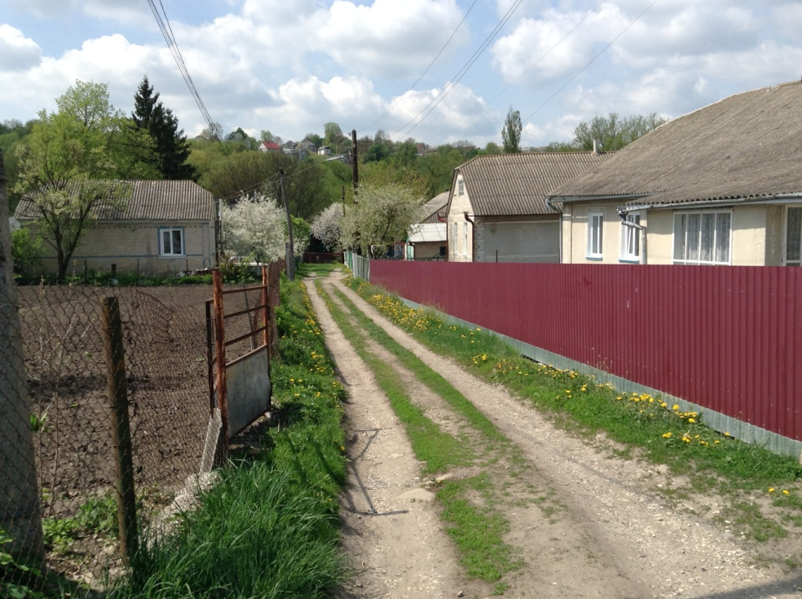
New houses in what was once the Jewish section of Gorodok

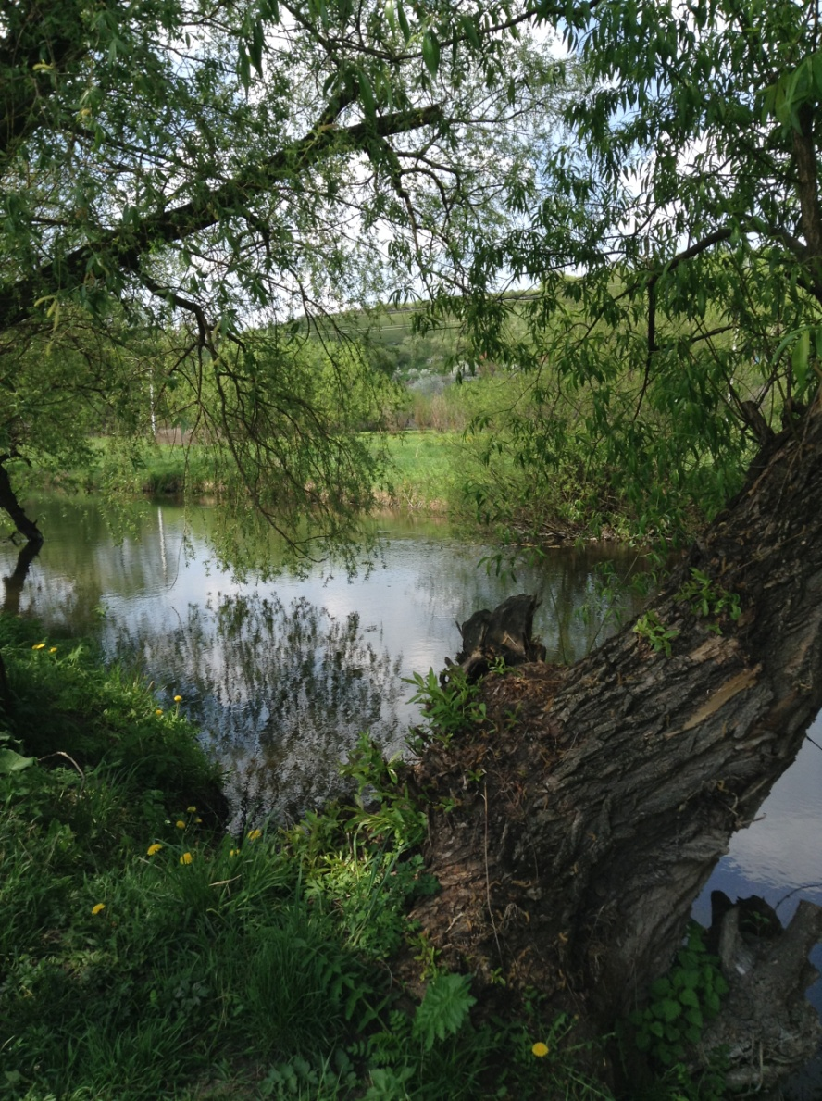
Smotrych River (a lot smaller than I had imagined) that flows by Gorodok

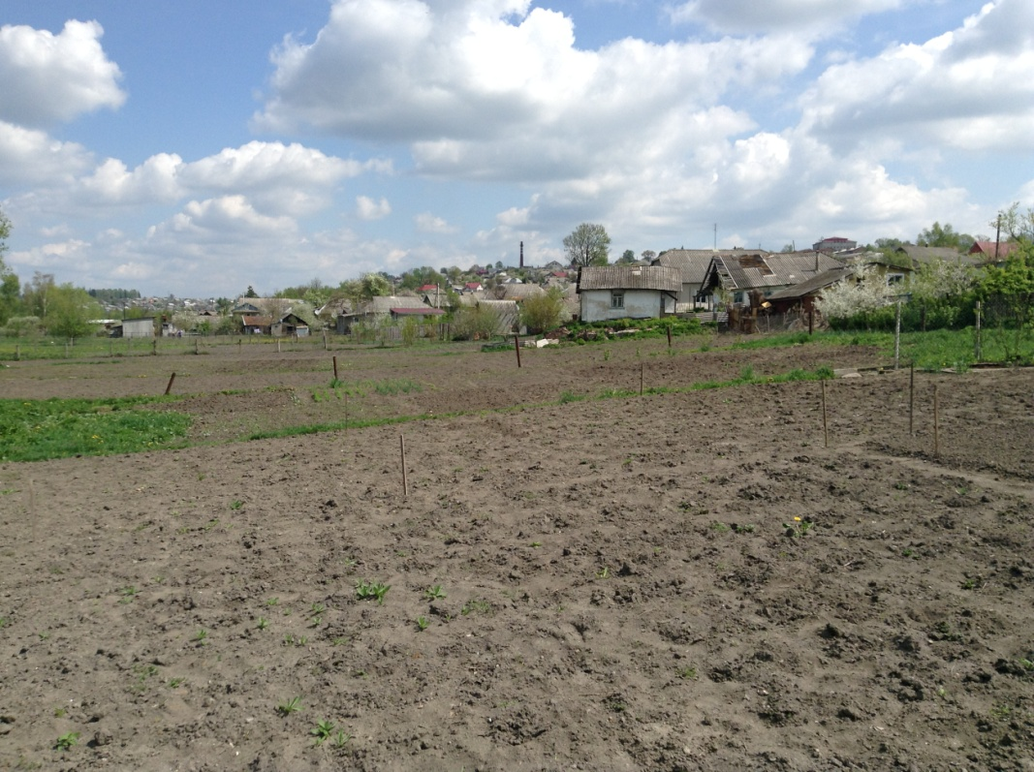
Houses and gardens along the Smotrych River

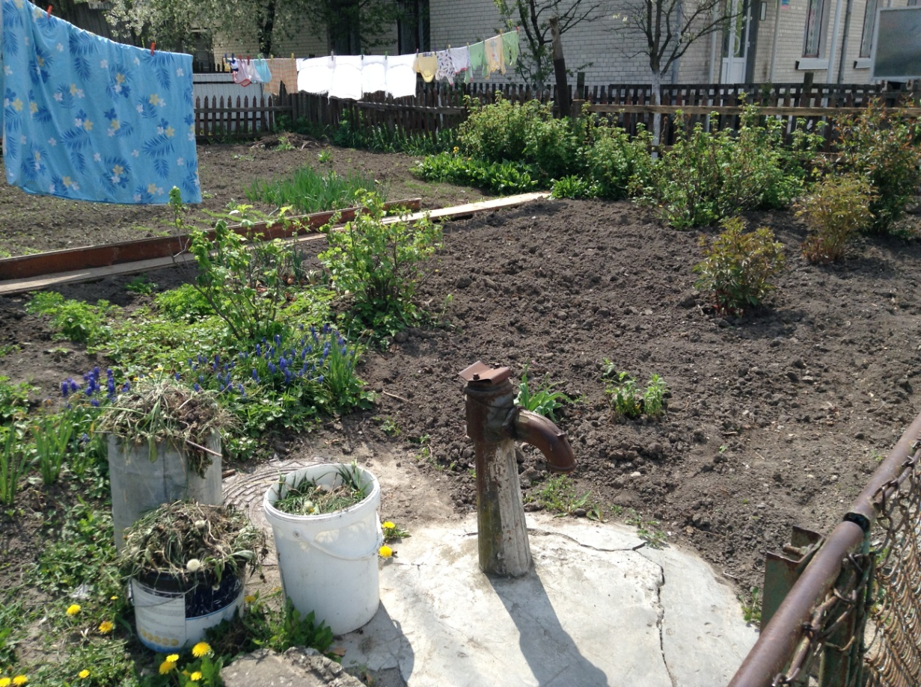
This was once the well in the center of the town
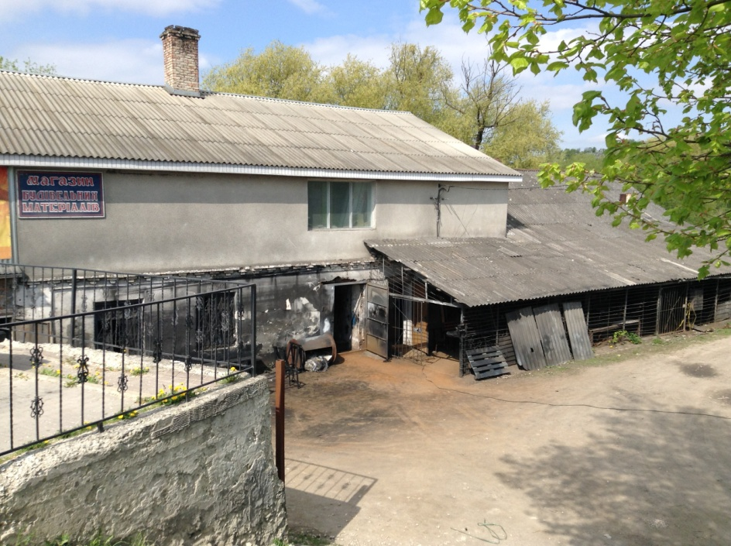
Original site of mikvah, which was close to one of Gorodok’s
two synagogues.

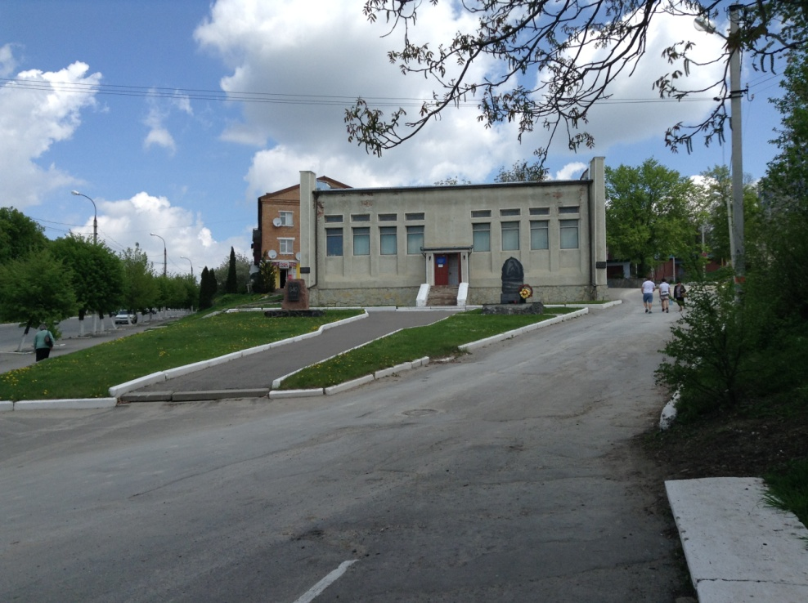
Horodok (Gorodok) Museum
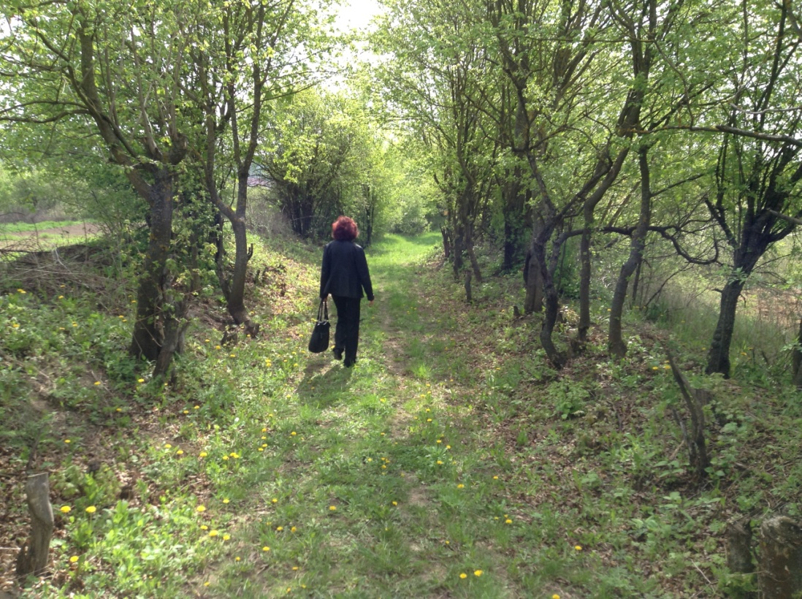
Path to Jewish cemetery located on a hill across the river from Gorodok

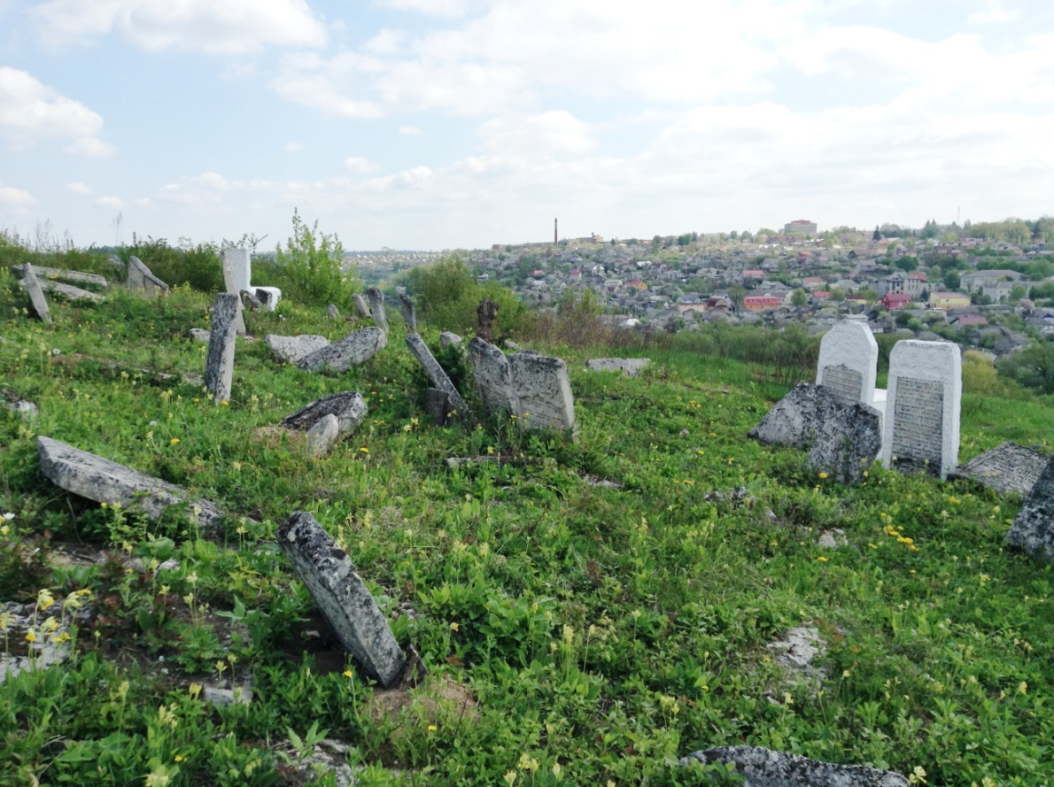
Jewish cemetery with Gorodok in background. The cemetery, which is quite large,
contains graves from the 17th through the 20th centuries. We were told that there
is no plot plan available that would make it easy to identify graves by family.

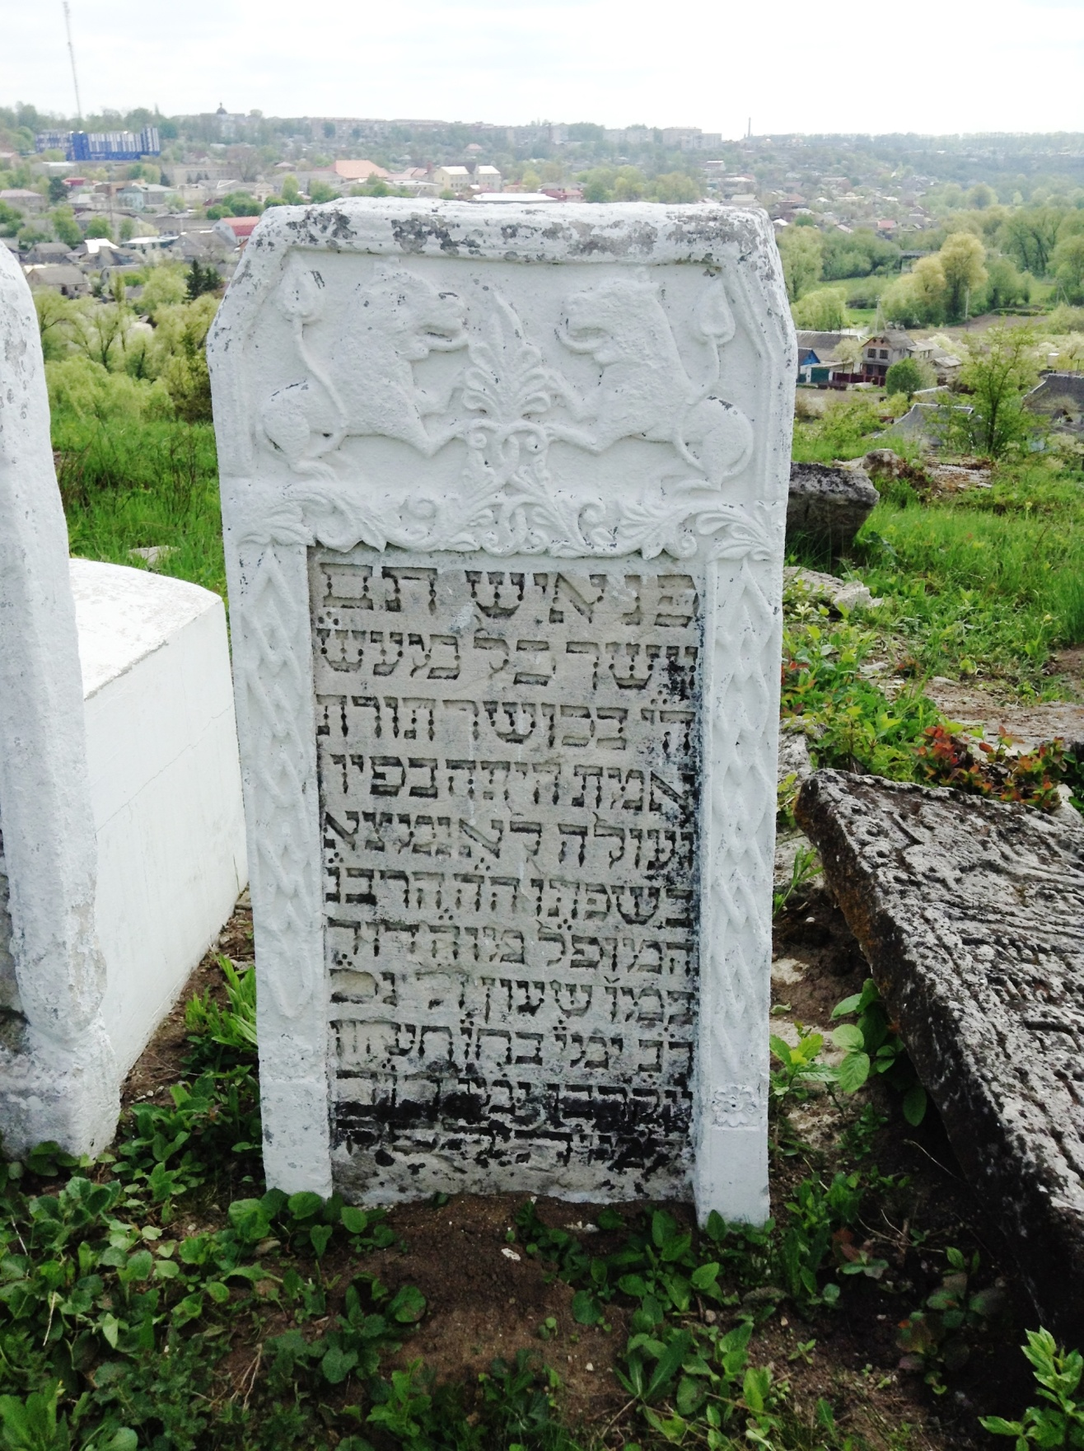
Detail of a tombstone
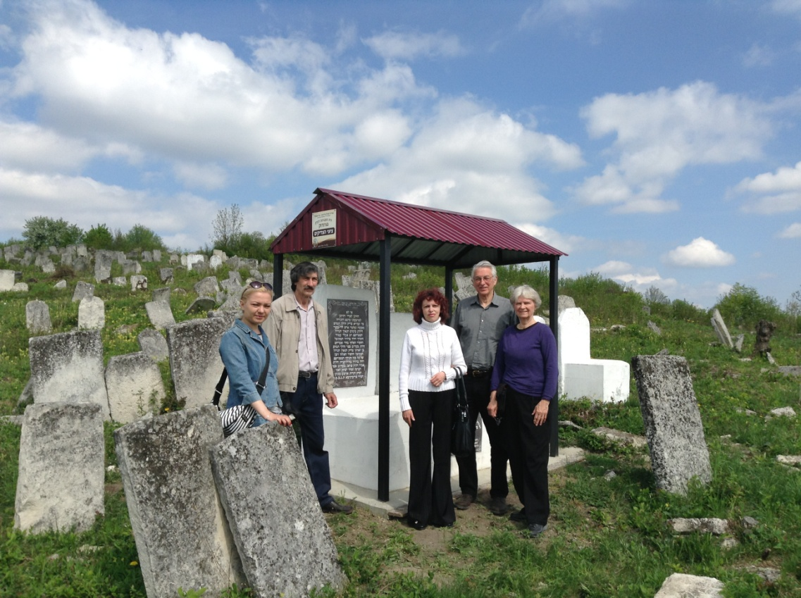
From left to right: Irena, our Ukrainian interpreter; Ilyago and Raisa our
Jewish guides; Steve and Joyce (his wife)

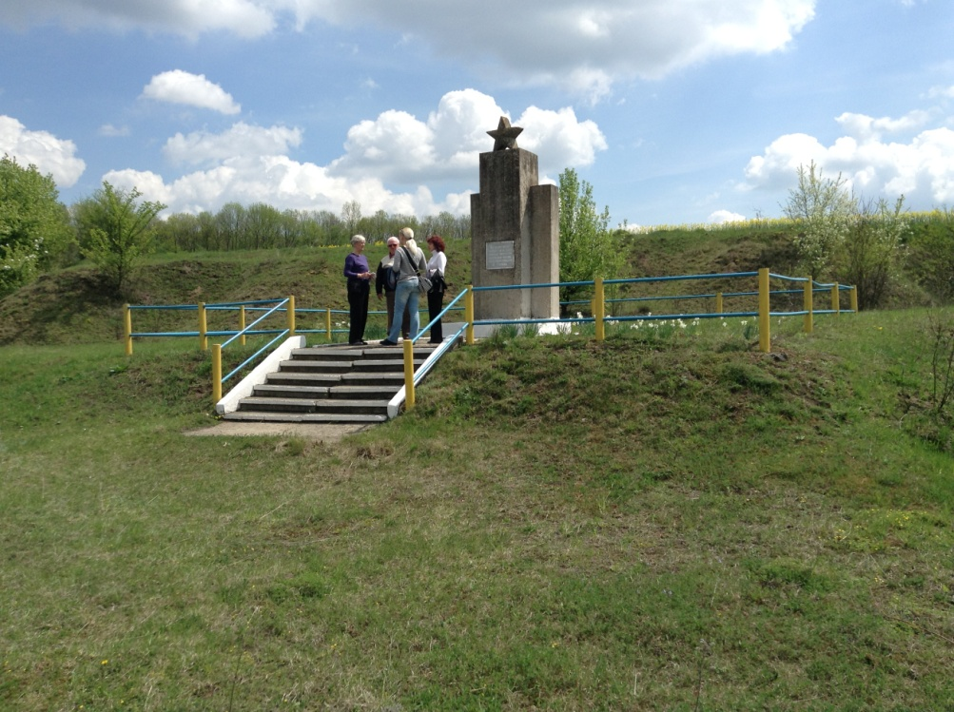
Memorial to Jews killed by the Nazis on the outskirts of Gorodok
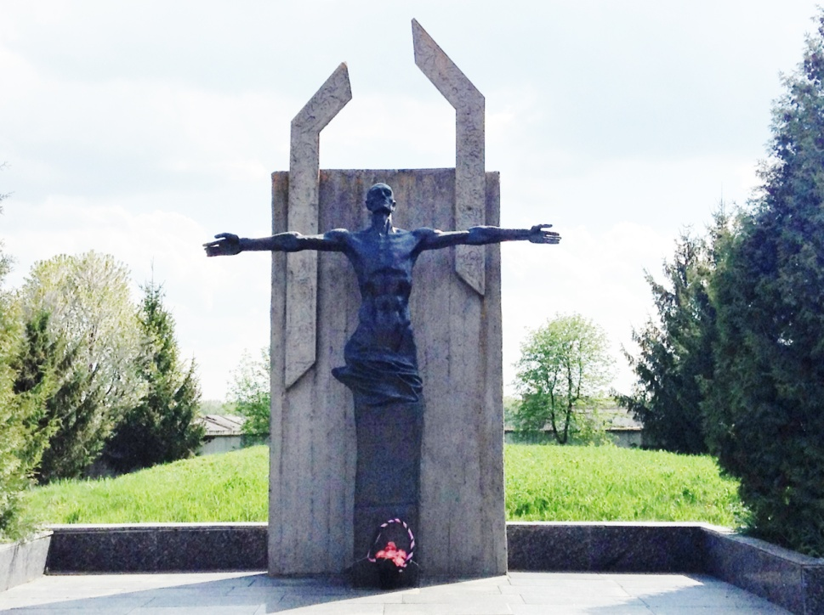
Memorial at Yarmolyntsi, a town 15 miles east of Gorodok where
many Gorodok Jews and Soviet soldiers were killed by the Nazis.

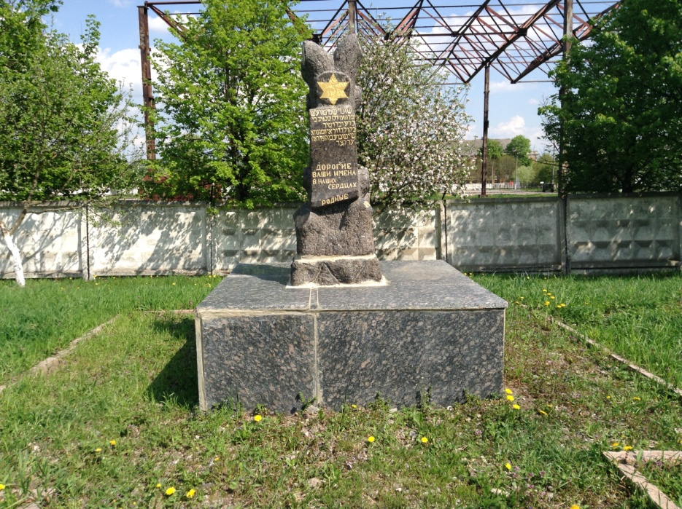
Memorial to Jews killed at Yarmolyntsi by the Nazis

