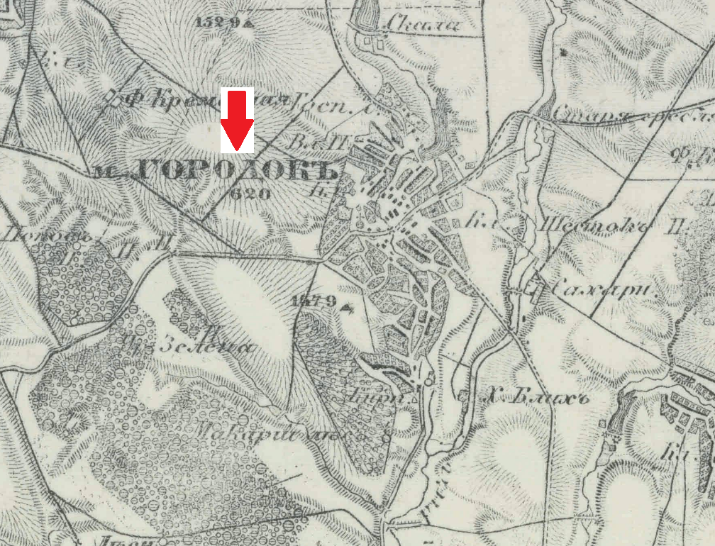
First from a late 19th c. series- (the spelling of the name is different than the first two I sent; note the symbol for the church in the middle of the town and the figure for dwellings is 620 in this 1877 view, at the southern tip of the town is a symbol for a tavern, the circle with the little flag)
Here is the access page: http://easteurotopo.org/indices/view/view.php?map=mrtindex&section=Yarmolintsy

