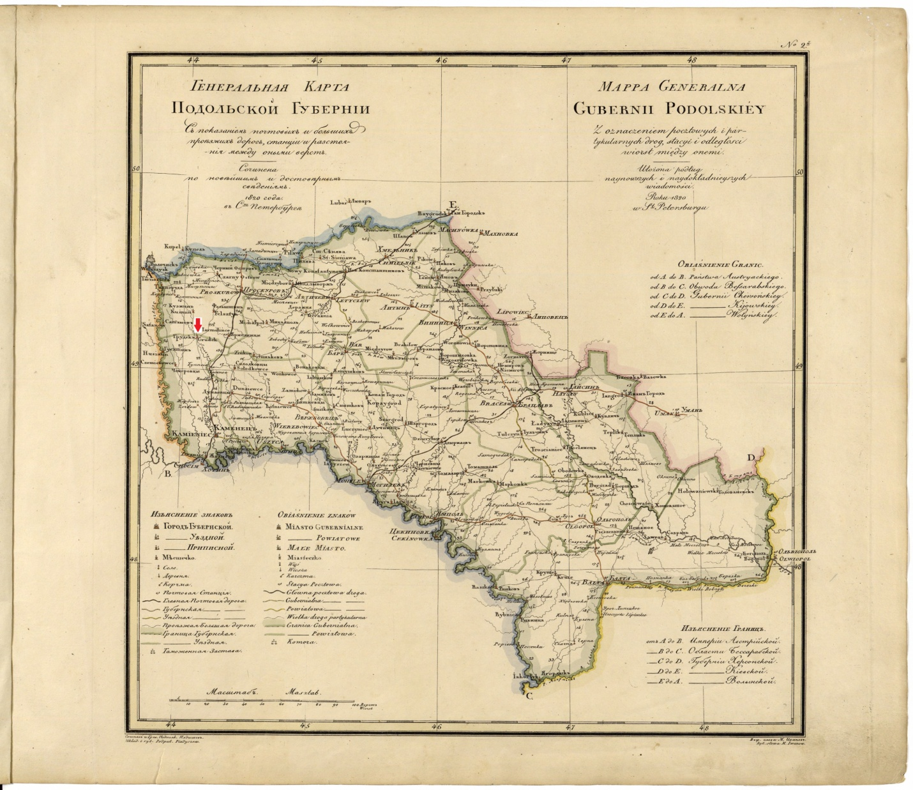
http://easteurotopo.org/indices/zoom/zoomviewer.php?attribution=World%20Digital%20Library&fileurl=/images/provincial%20and%20atlas%20maps/Geographical%20Atlas%20of%20the%20Russian%20Empire%20%26%20Kingdom%20of%20Poland/Podolia_1820_Pyadichev.jpg

