Dollen Family
Genealogy

contributed
by
Sheri Dollin McAdoo
(grand-daughter of Harry Dollin)

Jacob Dollen
born in 1856 in Yelisavetgrad, Russia
died in 1908 in USA at age 52
married Hannah
Hannah was born in Russia
died in 1919 in USA
children: Max, Abraham, Ida, Morris, and Jacob

Max Dollin (a.k.a. Dollen)
born on 10 August 1876 in Yelisavetgrad (Kirovograd), Cherson Oblast
died in June 1931 in Boston, MA at age 54
Occupation: Paperhanger
Immigrated 04/18/1900 to NY from Hamburg on SS Pretoria
Naturalized 03/25/1912
married Anne (a.k.a. Hannah; Henya) Kaplan 29 January 1901 in Yelisavetgrad
daughter of Lewis (Lazar) Kaplan and Sonya Muldafsky (1878 – 1942)
died in 1973 in Boston, MA
buried in "Pride" Section Of Woburn Jewish Cemetery
children: Libby, Harry, Joseph, Shirley Gertrude, Rose, Frances, and Frank Arthur

Libby (a.k.a. Lillian)
born 9 September 1901 in Boston, MA

Harry
born 8 June 1904 in Boston, Mass
died 6 July 1983 in Scottsdale, AZ at age 79

Joseph (George)
born 13 April 1908 in Framingham, MA
died 26 November 2001 in Hollis Hills, NY at age 93
occupation: physician

Shirley Gertrude (born Sarah)
born 13 November 1910 in Boston, MA

Rose (Ootie)
born 11 September 1912 in Boston, MA
died March 1989 in Milton, MA at age 76

Frances
born 23 August 1915 in Boston, MA
died 2011

Frank Arthur
born 1903 in Boston Mass
died 1903

Lewis (Lazar) Kaplan and Sonya Muldafsky
children:
Anne
Samuel (1873 - 2/19/1936 died in Boston)
Abraham (died in New York)
Fannie (1867 - 1913 died in Worchester, MA)
Clara (1886; died in Worchester, MA)

Note: people whose names are in Bold were born in Yelisavetgrad.

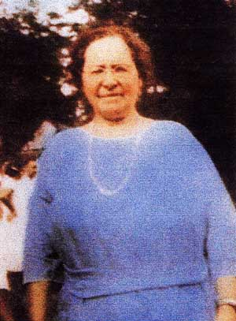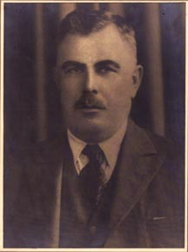
Anne Kaplan Max Dollin (a.k.a. Dollen)

