Resnick, Selon and Gordon
Family History
in
Kherson

compiled
by
Susan Dressler

Maternal Grandmother’s Family Names

Gorodokin to Gordon
Grandmother Taube “Tillie” Gorodokin,
mother of Mildred Stern

Selon
Great-Grandmother Basche “Bessie” Selon Gorodokin,
mother of Taube Gorodokin

Resnick
Great-Great-Grandmother Ethel Resnick Selon,
mother of Bessie Selon
_______________

Tillie GORODKIN, Kherson, Ukraine 1896
Taube (Tillie) Gorodokin
(later changed to Gordon)
Russia (now Ukraine)
Kherson, Kherson Gubernia
Latitude 46°, 38'; Longitude 32°, 35'
East of Odessa

Immigrated in 1911
(Liverpool to Quebec to St Alban's, Vermont
to Chicago, Illinois)

The Resnick, Selon, and Gorodokin Families
(excerpted from a book I wrote on my family history)

What’s in a Name?
Surnames: Gordon is the name that one line of our family adopted upon arrival in America. It was not the married surname that our great grandmother (Bessie Gordon) had when she left the city of Kherson in the part of Russia now known as the Ukraine.

Our family name there was either Gorodokin or Gorodkin which in Russian means citizen of a small city. Bessie’s maiden name was Selone which means green. My great-great grandmother (Ethel Resnick Selone – pronounced Selonee) and her children changed their surname to Selon as they began to reach for the American dream.

Changing Surnames and Given Names
Part of the Transition to Being American

YIDDISH | ENGLISH
Gorodokin or Gorodkin | Gordon
Selone or Zelone | Selon
Reznik or Riznik | Resnick

YIDDISH | ENGLISH
Basche | Bessie
Taube | Tillie
Hilke or Hillel | Harry
Jankel | Jack or Whitey
Meyer | Max or Mickey
Butzik | Ben
Avraham | Abe or Abraham
Etta | Ethel
Moshe | Morris
Raisel | Rose
Hudel | Ida

What was the historical context for our family’s emigration?

Times were getting even more difficult for Jews in the Pale. A variety of restrictions governing every day life had been imposed on Jews over the years. Stories of opportunity in America came back from those who had ventured out earlier. Basche Gorodokin’s husband, Semlach Lazar Gorodokin, died of lung cancer around 1906 or 1907 leaving her with seven children, the youngest of whom was an infant. (Semlach Gorodokin was a butcher, so the family was not well off.) Basche’s only daughter, Taube, could not go to the public school because a restriction had been put in place limiting the number of Jews in any school to 10%. Since education was valued in the family, Taube was sent to the only school that would take her, the one run by the Russian Orthodox Church, a place that willingly provided an education but also attempted to convert Jews to Christianity.

I am sure that the family discussed the difficulties that existed for them and the opportunities and the challenges that they would face if they emigrated. Even though they would be leaving behind family, friends, and all that was familiar, they decided to take a chance and make the journey.

The Gorodokin family arrived in America in small groups around 1910 prior to the beginning of World War I. Basche’s younger brother Hillel (Harry) Selon was the first to emigrate and he settled in Chicago. He was instrumental in helping his older sister Basche and her children emigrate and settle in Chicago also. Basche’s two oldest sons were sent to Chicago in the first wave of our family’s journey. Somehow Basche Gorodokin (age 41) and five of her children (Taube, Butzik, Hilke, Jankel, and Meyer (ages 16-3) followed. I have not been able to find any documentation identifying the first part of their journey from Kherson to England, although they probably sailed from Odessa to Liverpool, England. I was able to verify their journey from England to North America with the manifest of the S.S. Canada, the ship that the family took from Liverpool to Quebec, Canada. The ship left Liverpool on July 29, 1911 and arrived on August 6, 1911. From Quebec, Bessie and the children went to St. Albans, Vermont and enter the USA for the first time. According to the ship’s manifest, her sponsor was her brother and she headed to Chicago.

OUTLINE DESCENDANT TREE

(mggf) Semlach Lazar GORODOKIN
born circa 186? in Russia,
married
never emigrated,
d. circa 1905 in Kherson, Russia

(mggm) Basche>Bessie GORODOKIN>GORDON
born circa 1867 in Odessa, Russia
emigrated on 8/6/1911
d. 8/22/1953 in Chicago, Ill.
buried Menorah Gardens Cemetery, outside of Chicago, Ill.

(mgu) Abraham>Abe GORODOKIN>GORDON
born 5/12/1887 in Kiev, Russia
married Lillian>Libby
emigrated prior to 1911
d. 11/13/1966 in Chicago

(mgu) Albert>Al GORODOKIN>GORDON
born ? in Russia
married Dorothy
emigrated prior to 1911
d. 1/23/1945 in Chicago

(mgu) Butzik>Ben GORODOKIN>GORDON
born 4/17/1899 in Odessa, Russia
married Esther KRANDEL
emigrated on 8/6/1911
d. 8/7/ 1978 in Chicago

(mgu) Hilke>Harry GORODOKIN>GORDON
born abt. 1901 in Russia
married Jean
emigrated 8/6/1911
d. ?

(mgu) Jankel>Jack>Whitey GORODOKIN
born abt 1903 in Russia
married Bea
emigrated 8/6/1911
d. 1/22/1973

(mgu) Meyer>Max GORODOKIN>GORDON
born 15 July 1908 in Russia
married Helen
emigrated 8/6/1911
d. 1993 in Las Vegas

(mgm) Taube>Tillie GORODOKIN>GORDON
born 2/17/1896 in Kherson, Russia
married
emigrated 8/6/1911
d. 4/12/1988 in Los Alamitos, CA
buried Forest Lawn Cemetery, Long Beach, CA

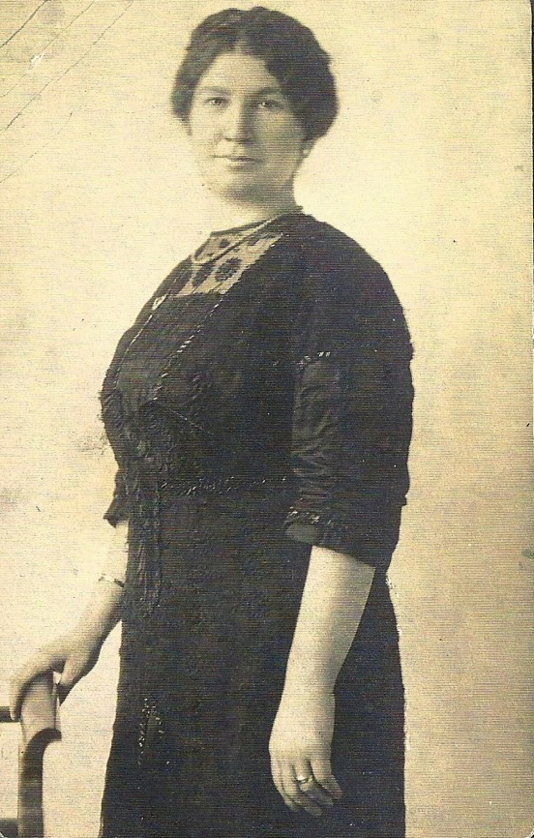
Ida Selon (Buyer)
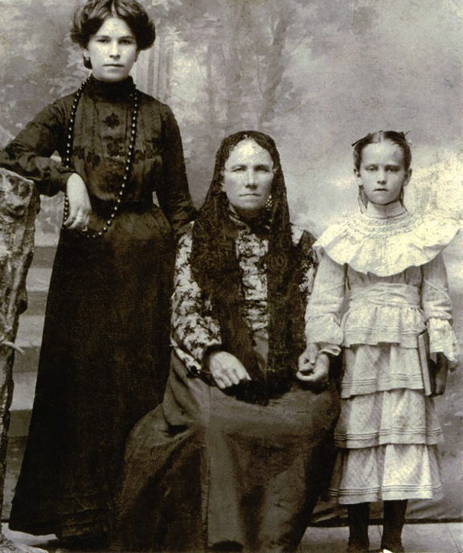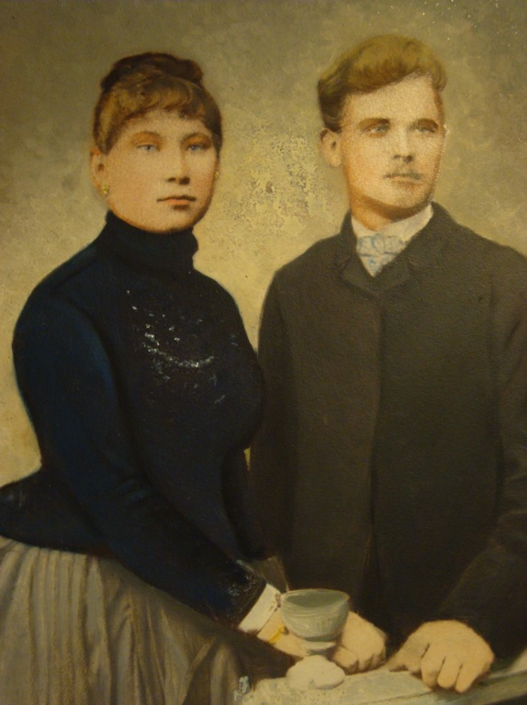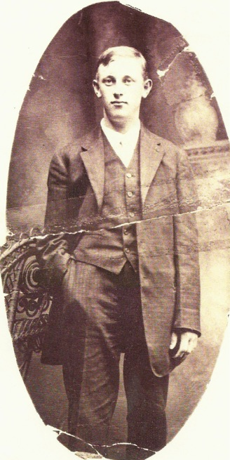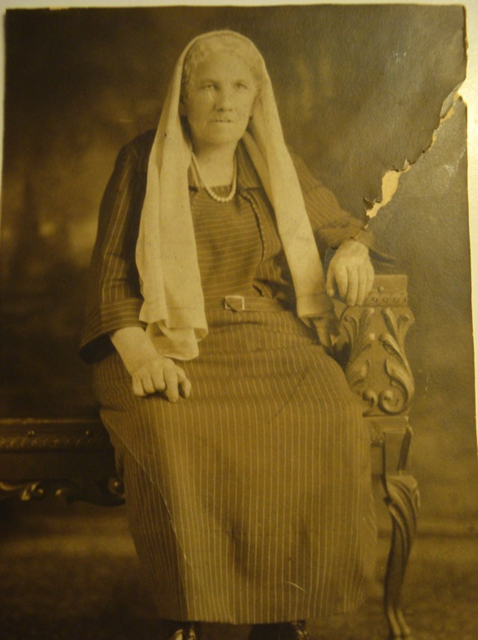
Left: Basche Selon Gorodokin
Middle: Ethel Resnick Selon
Right: Taube Gorodokin
Wedding Photo
Basche Selon and Semlach Lazar Gorodokin (about 1883)
Avraham Gorodokin
(later known as Abraham Gordon)
Ethel Resnick Selon

