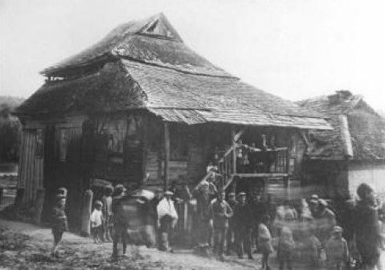
One of Gorodok’s two synagogues.
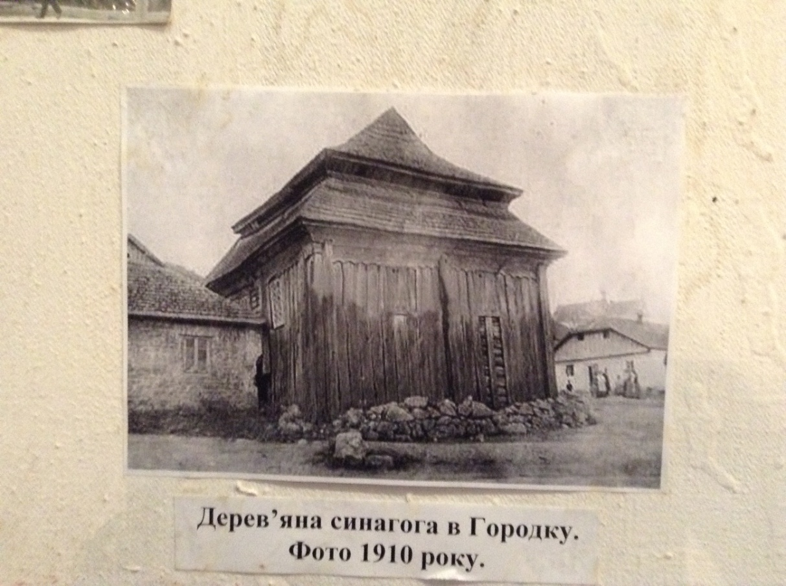
Gorodok synagogue early 20th century. Is this the front side of the above or is it the second synagogue?
Gorodok, Traders’ Row, late 19th century

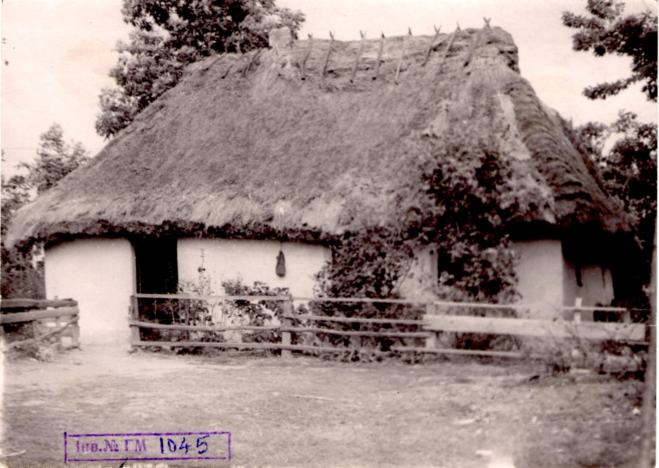
Farmhouse from Early 20th century

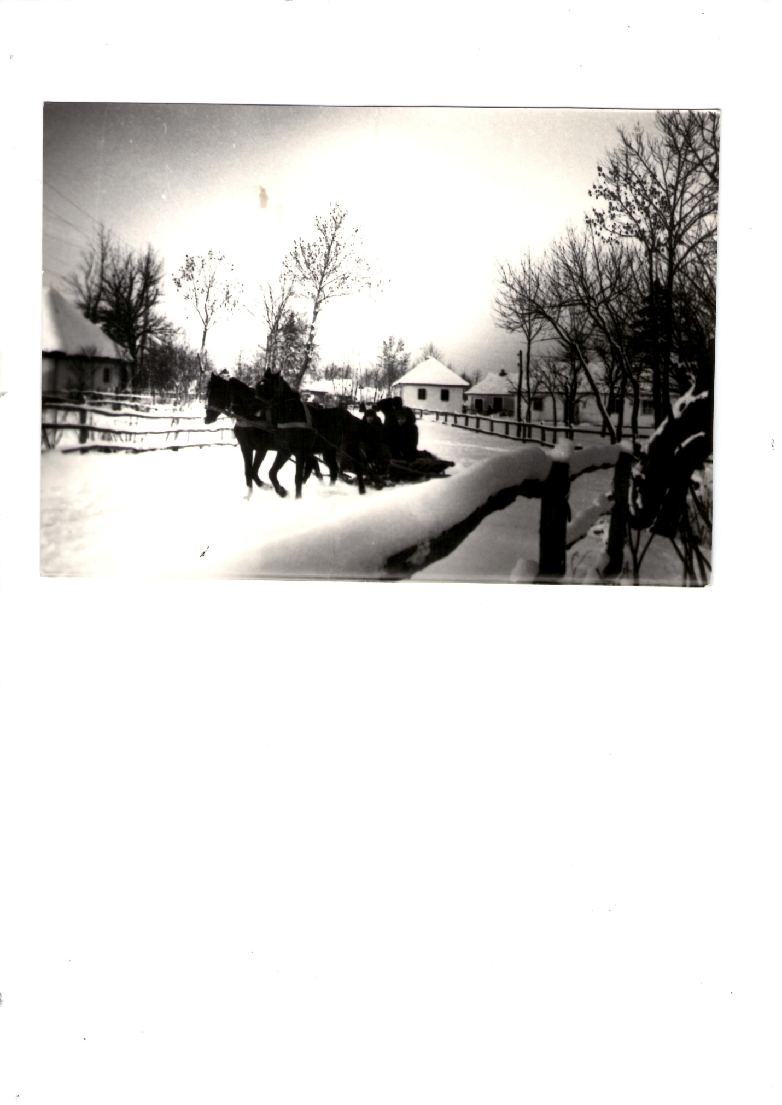
Winter scene in Gorodok
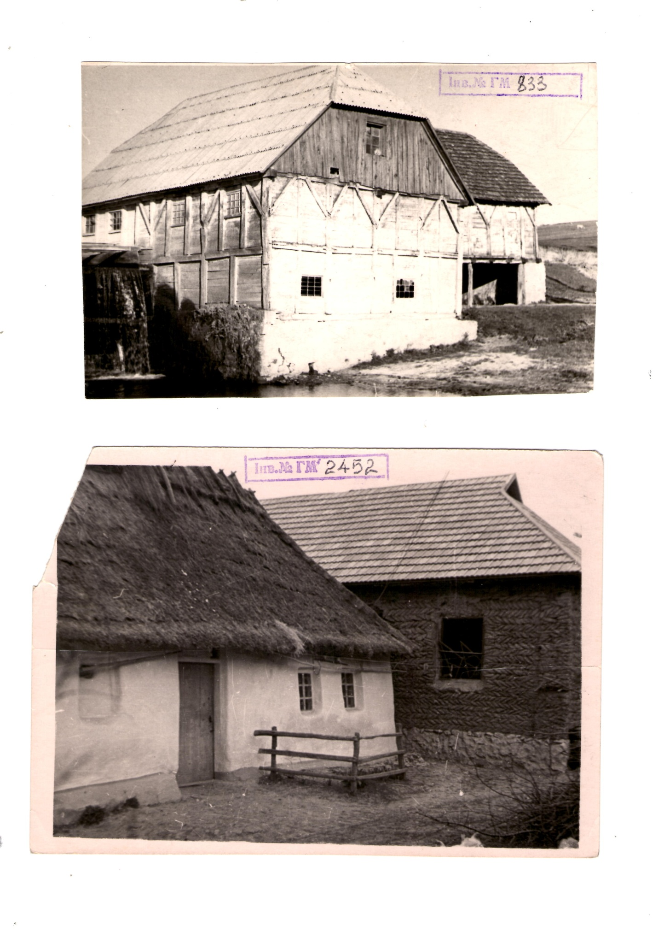
Houses 19th- early 20th century

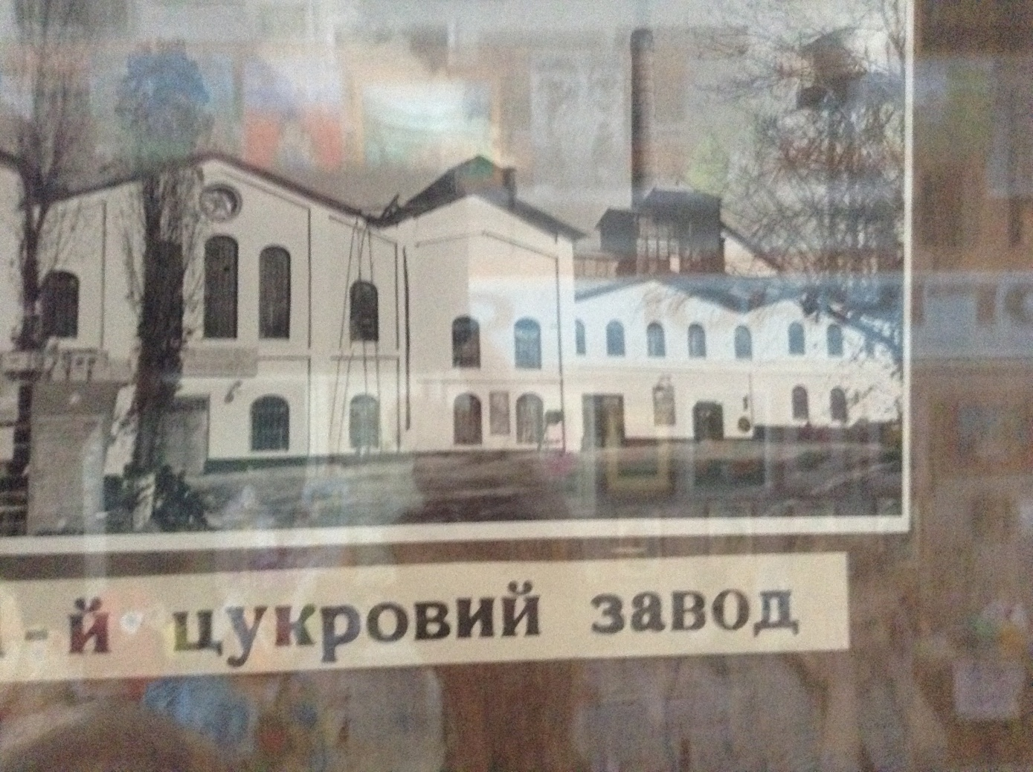
The old beet sugar mill in Gorodok.
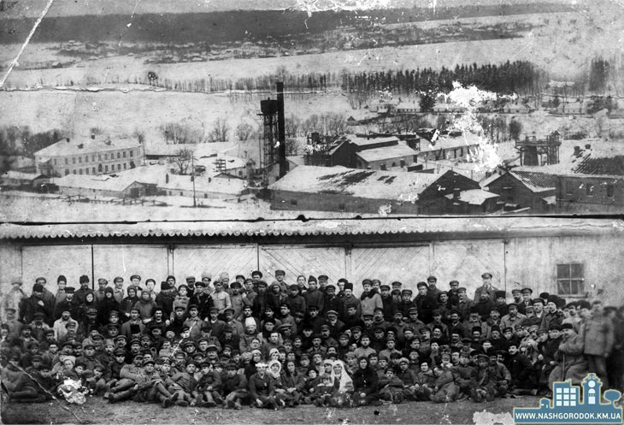
Sugar mill factory workers
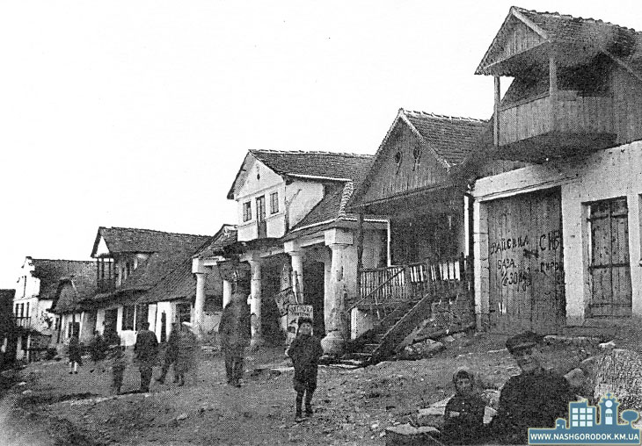
Gorodok in the 1930s.

Photos in this document are from the Horodok (Gorodok) Museum to which we are greatly indebted.

