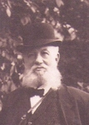
Shmu I Michelsohn 1840-1923
Liquor salesman

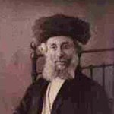

His father Ural 1820-1909
He was very scholarly and went to
Palestine in 1899 with his
second wife. Lived in Jerusalem.-

Ural Michelsohn
Gender: | Male
Birth: | 1820  Latvia
Death: | 1909 (89)  Jerusalem, Palestine
Immediate Family: | Son of Aron Michelsohn and Rebecca  Husband of Rasse michelson and Dina Rosenberg  Father of sawel urel(samuel) michelson; Shmuel I. Itzik Michelsohn; Mina-Rosa michelson; Honne Michelsohn; Channe-Braine Michelson and 5 others  Brother of Laser Michelsohn; Rachle Michelsohn; Henne Michelsohn; Rase Michelsohn and Yossel Michelsohn

