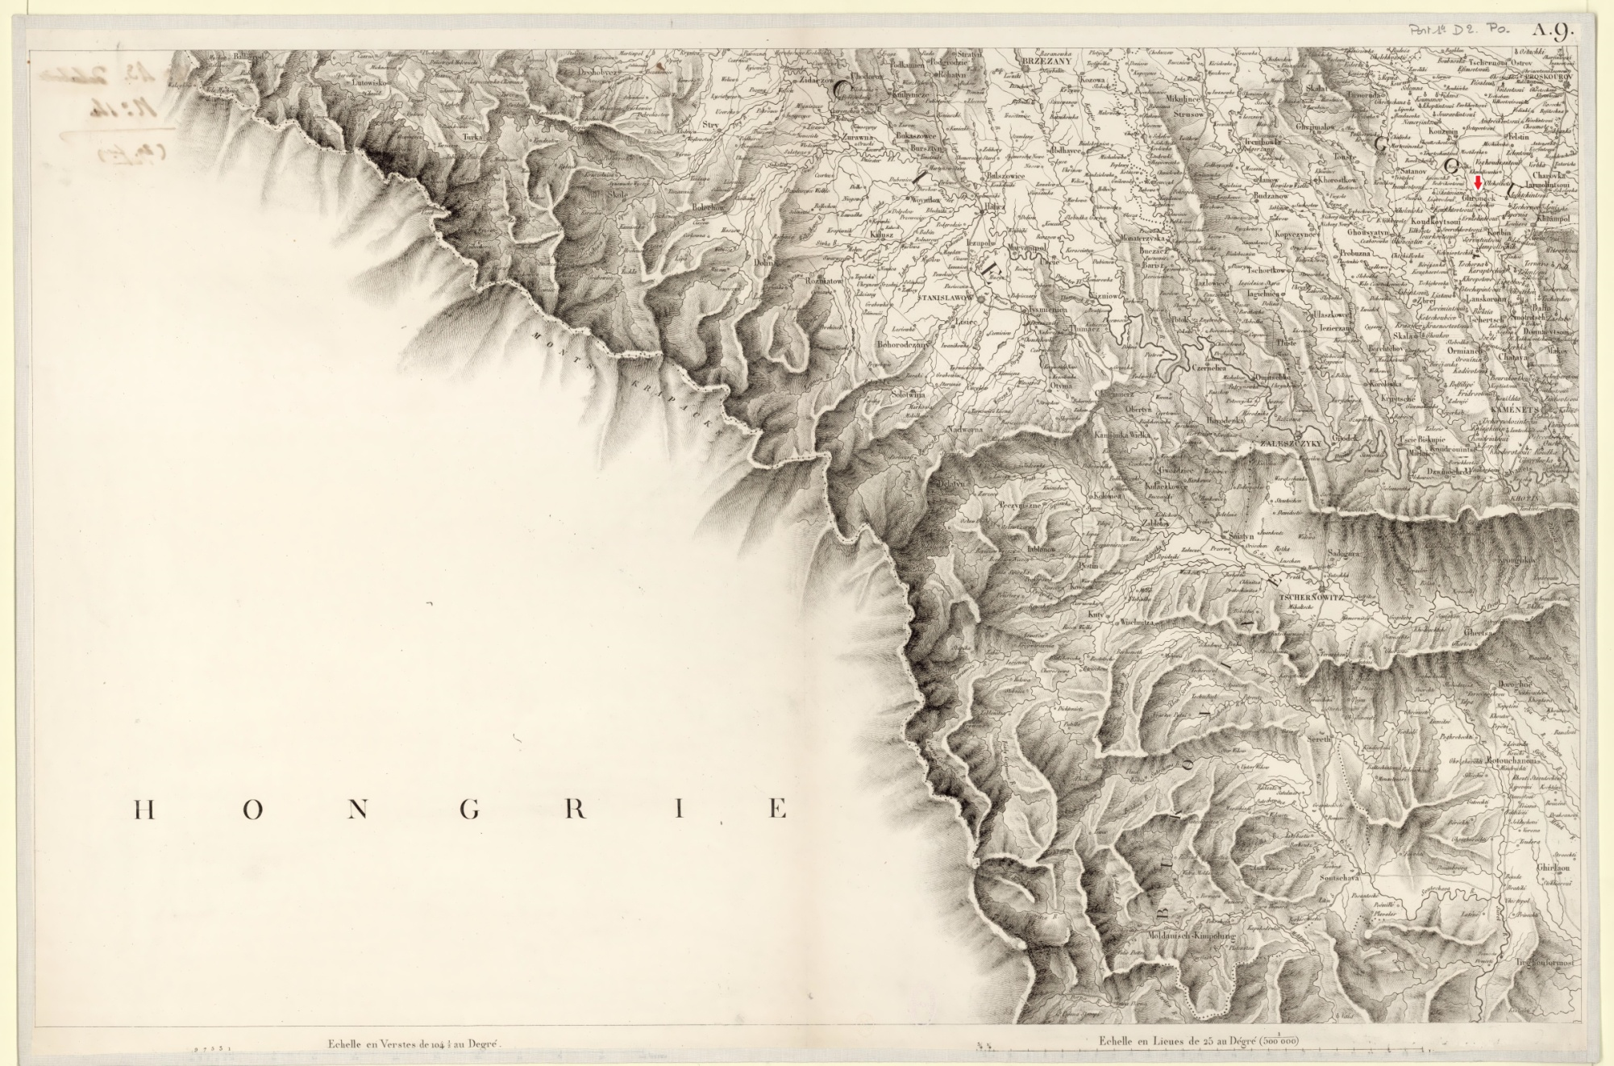

This if from a French series in 1812, maps used by Napoleon. Note the county border north of the town. The provincial borders in these maps are very distinct. The full map is viewable or downloadable here:
http://easteurotopo.org/indices/view/view.php?map=CREindex&section=Kamenets. We don't have very many French maps of eastern Europe and so the spellings seem rather odd. This map is from a system that is being readied for the main site: http://easteurotopo.org/indices/test-carte-russie/

