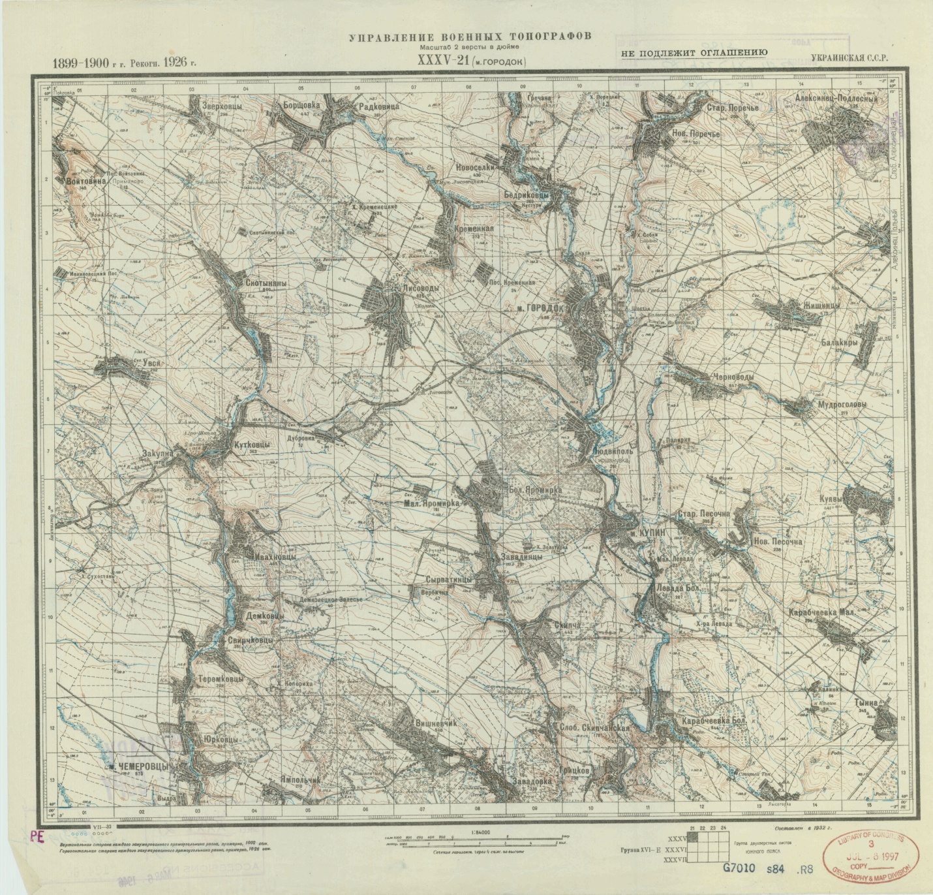
Here is a map from the post revolution period: (the number of dwellings has swelled to 1,468-not too surprising, the fact that we do not see an inscription for the Jewish cemetery may have something to do with it being the post revolution period when religion was discouraged)
The access page is here: http://easteurotopo.org/indices/view/view.php?map=s84index&section=Proskurovskiy%20Gorodok

