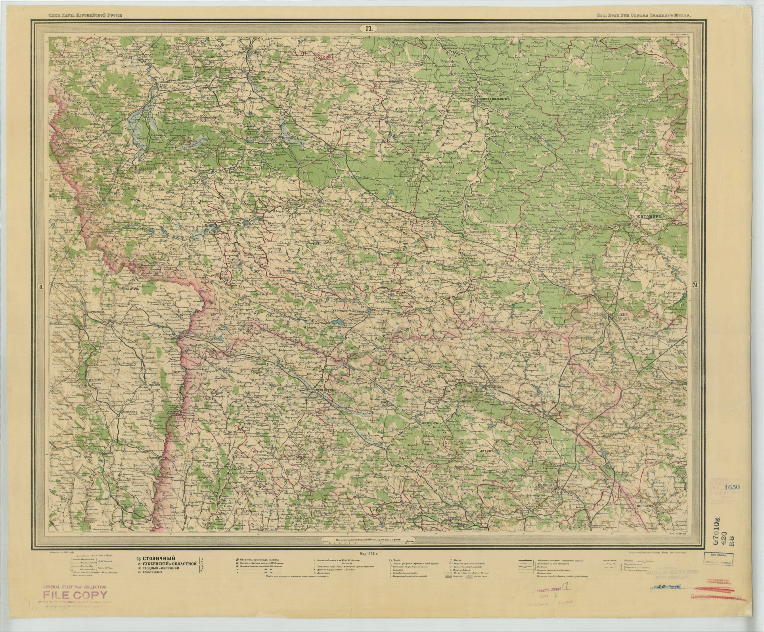
This is from a Russian series, Gorodok is right near the center of this screenshot. The number 69 can be seen below the name "Grudek". The date of this map is 1902, and usually the number below a town name represents the number of dwellings in the town. However we would expect there to be many more than 69 dwellings in this year and it might be from the first issue of this map which was more like 1867. You can see this latter date in the lower left of the map image. The map can be reached from this page:
http://easteurotopo.org/indices/view/view.php?map=SERindex&section=ZHITOMIR. This is from an index system also being prepared for full site viewing and will appear soon, http://easteurotopo.org/indices/test-ser/. The large shaded red line in the left of the map is the provincial border, actually the country border next to Austrian Galicia, the small sharp lines on the map are the county borders. The northern border of Kaminets county in this map is very convoluted.

